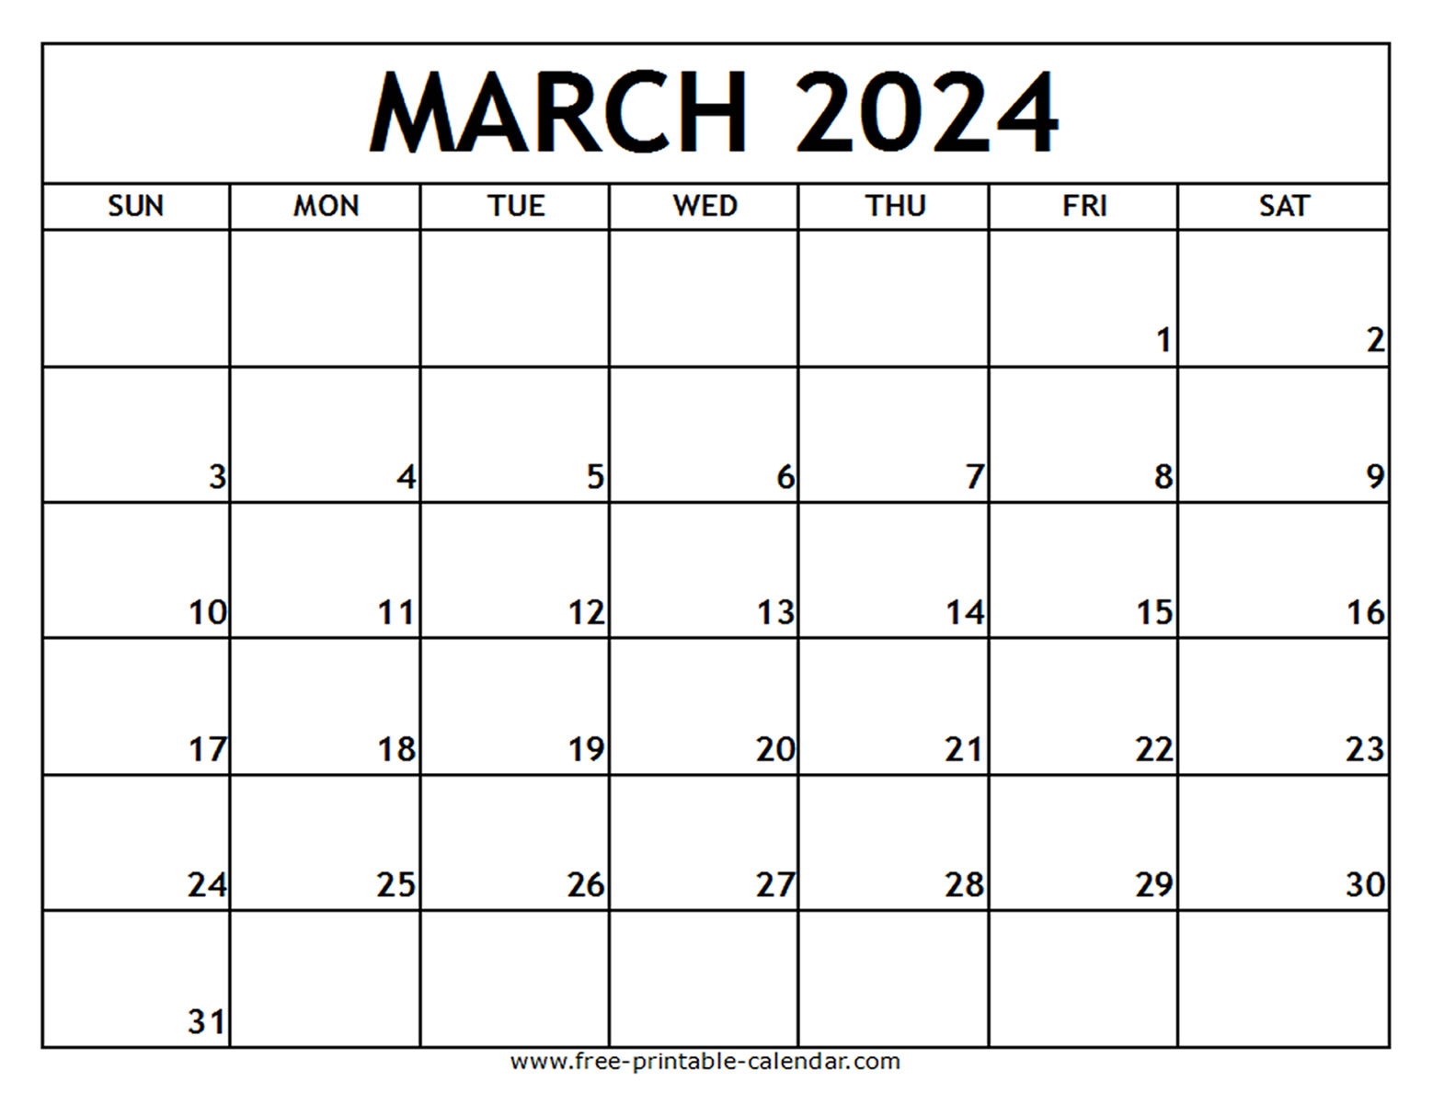

**WORD AND BIBLE VERSE OF THE MONTH** FAITHFULNESS Great is your

FAITHFULNESS Lamentations 3:23

Easter Party

MUSIC



**THEMES:** Pond Animals. Weather, Nutrition, St. Patrick’s Day

**COLORS**: Green, Blue **SHAPE**: Clover. Oval **LETTERS**: V, W, X **NUMBERS**: Review

MUSIC

CHAPEL

CHAPEL

CHAPEL

CHAPEL

MUSIC

MUSIC





LIBRARY VISIT





 