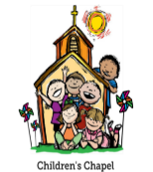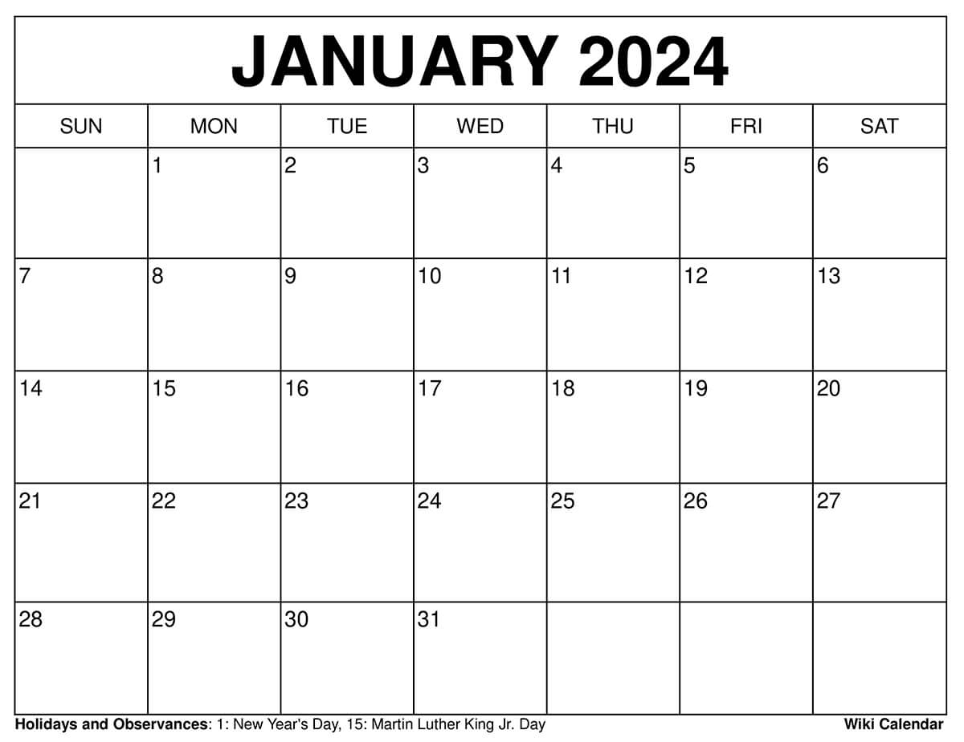

Library Visit

**THEMES: Dr. King, Winter, Snowy Day, Winter Animals COLORS: White and Black SHAPE: Circle, Oval LETTERS: D, P, B, R NUMBERS: 8, 9**

**KINDNESS: BE KIND TO ONE ANOTHER EPH. 4:32**

TEACHER WORKDAY

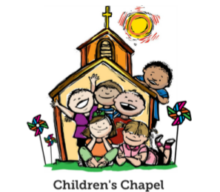CHAPEL

CHAPEL

CHAPEL

NO SCHOOL

MLK,JR DAY

TEACHER WORKDAY

**MUSIC**

**MUSIC**

**MUSIC**

**MUSIC**

**EXOTIC ANIMAL ENCOUNTER VISIT**



SCHOOL RESUMES





**JANUARY**