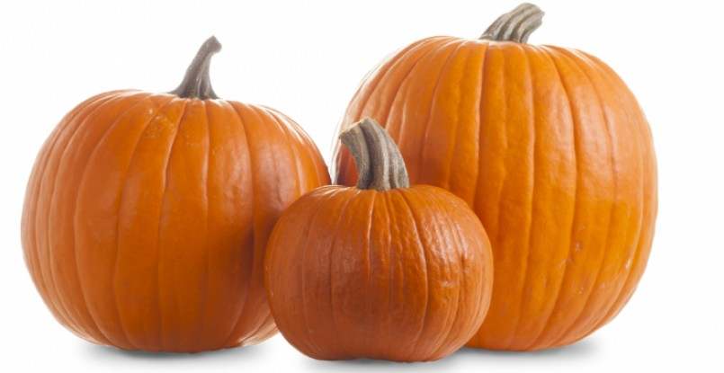 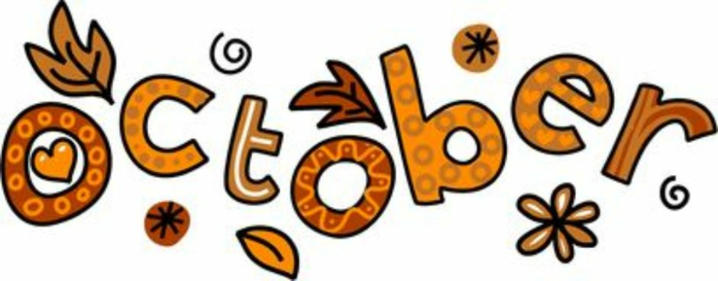 

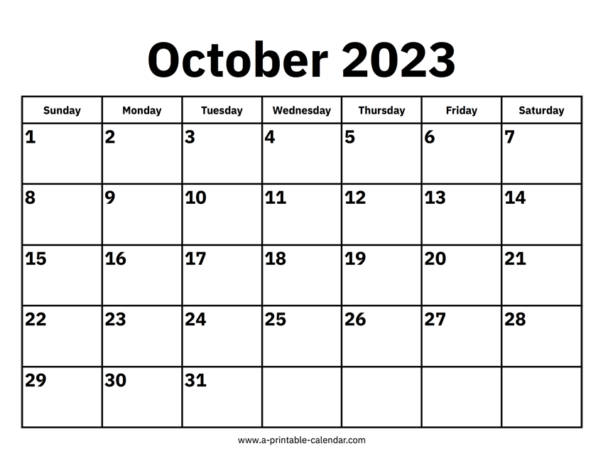

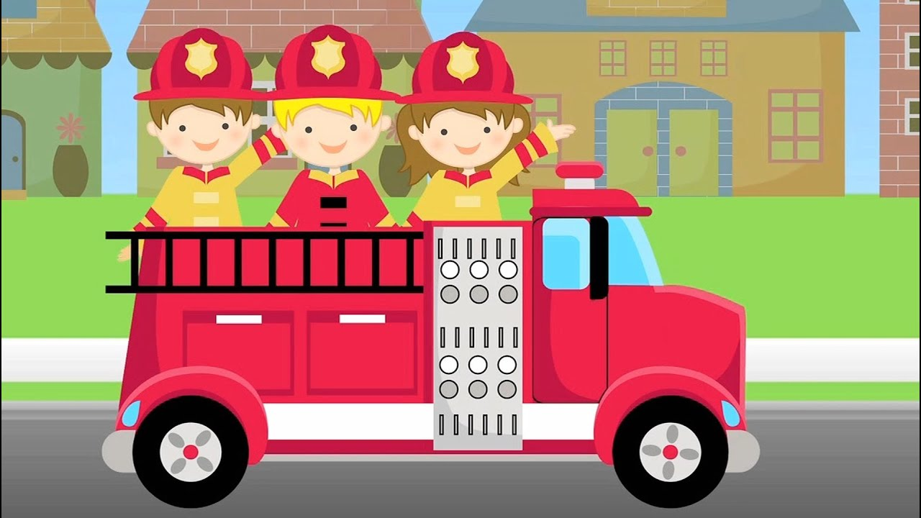**FIRE TRUCK VISIT**

10 AM PARKING LOT

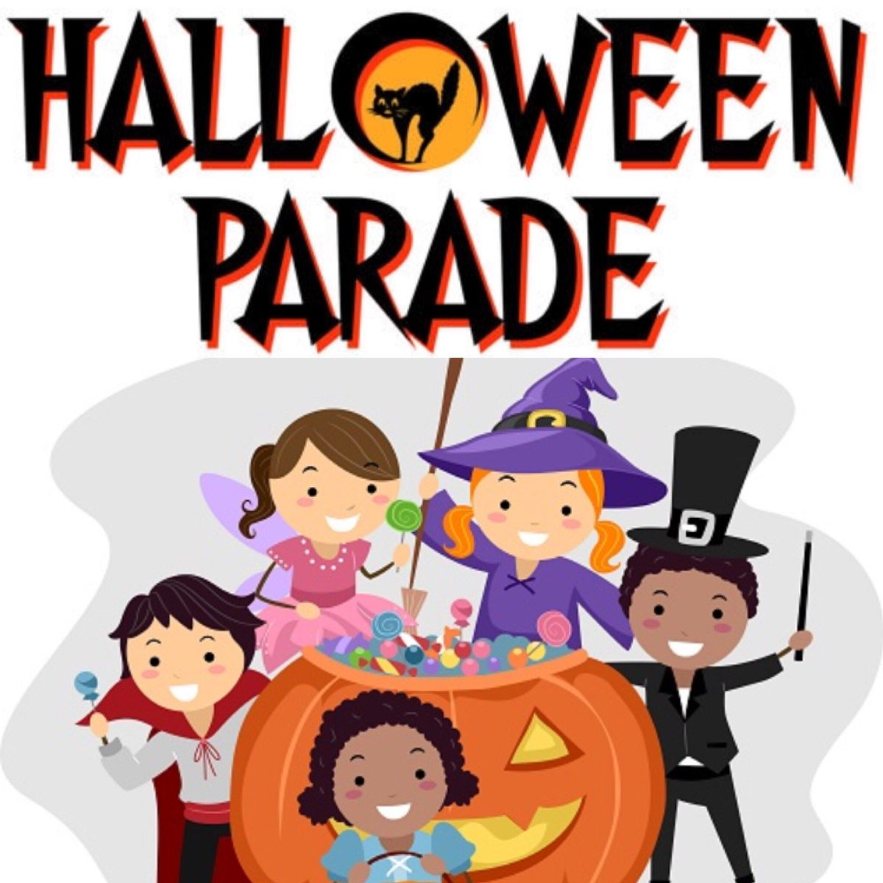

**THEMES: Autumn, Pumpkins, Fire Safety, Night Creatures**

**Letters T, I, U, C** **Numbers 2,3**

**Joy-Psalm 95:1a Come, let us sing for JOY to the Lord**

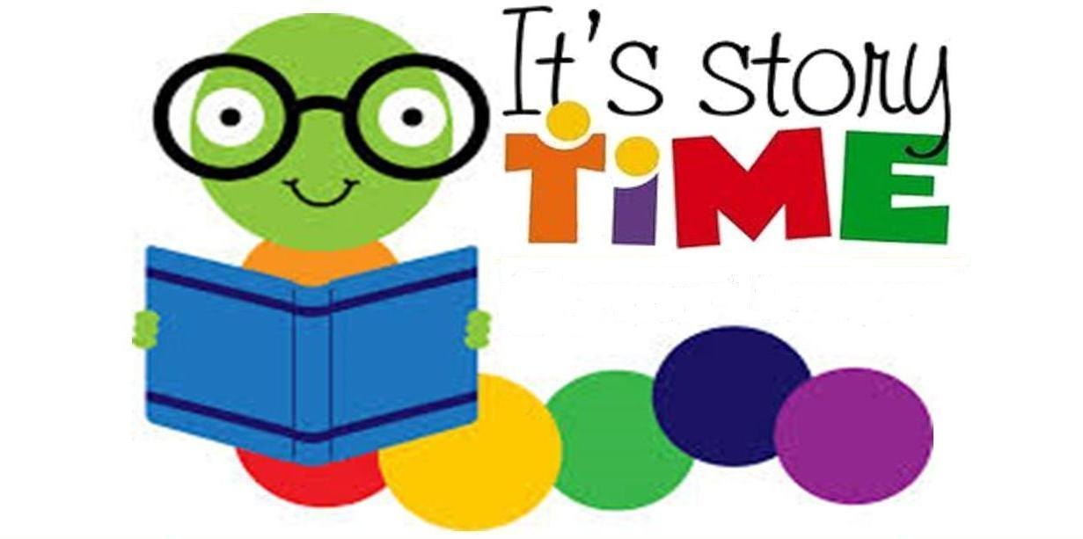Library Visit

MUSIC 

MUSIC 

MUSIC 

