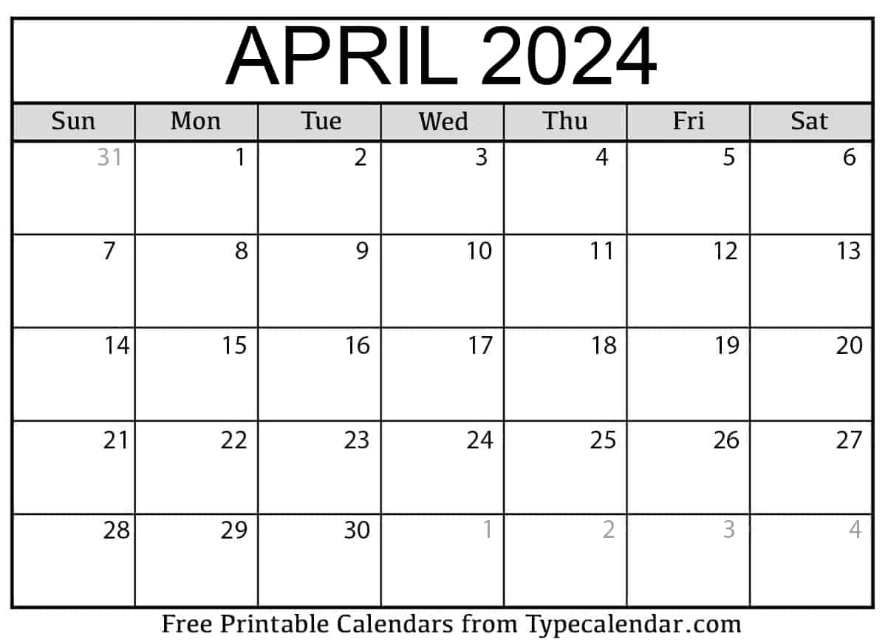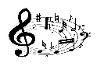

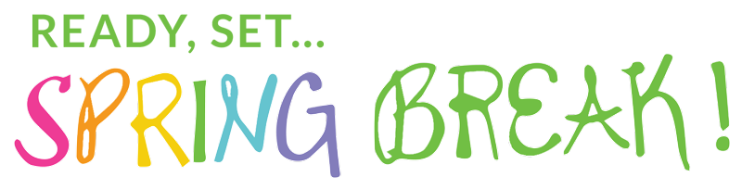

chapel

chapel

chapel

music

music

music

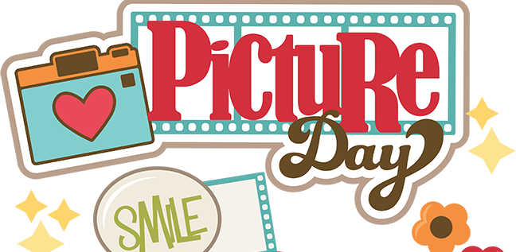

Library Visit

THEMES: Earth Day, Spring, Baby Animals

COLORS: Yellow SHAPE: Diamond and Oval

LETTERS: Y and Z NUMBERS: Review 6-10

