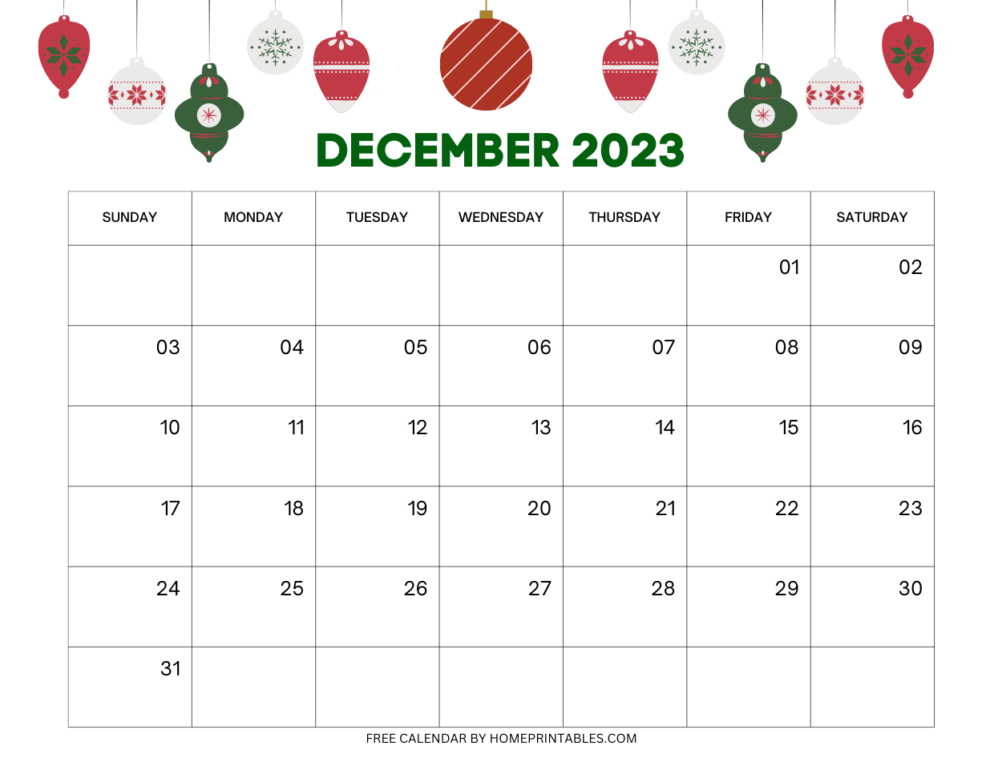

NO SCHOOL

CHRISTMAS BREAK

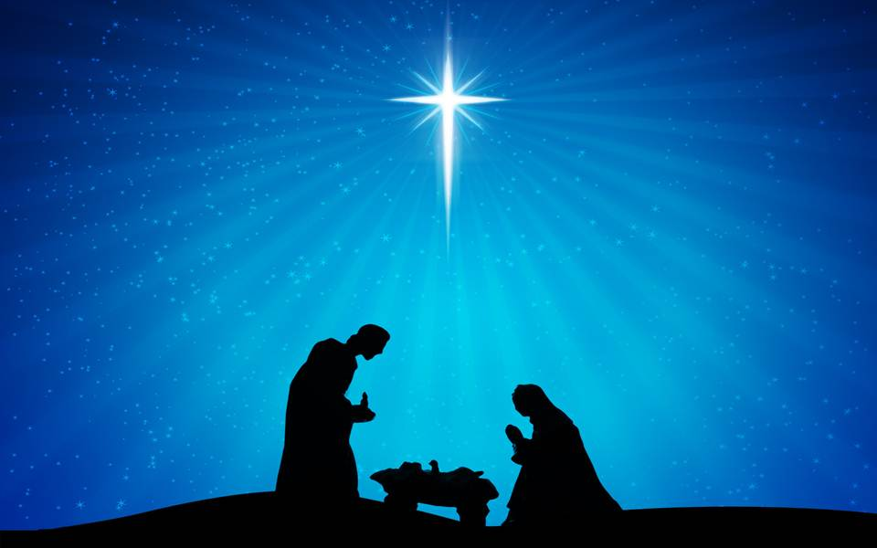

TEACHER WORKDAY

SCHOOL RESUMES



4

3

2

1

**10:00AM CHRISTMAS CONCERT**

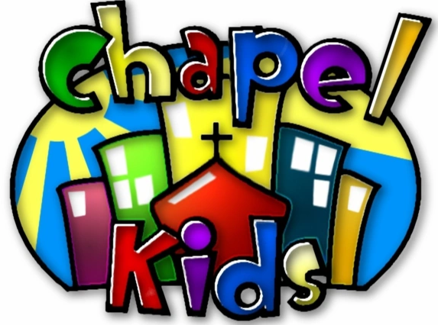



MUSIC 

MUSIC 

**BIBLE VERSE OF THE MONTH**

**FOR UNTO US A CHILD IS BORN**

**THEMES:** CHRISTmas, Jesus’ Birthday

**COLORS**: Red, Green

**SHAPE**: Star **LETTERS**: S, J **NUMBERS**: 6, 7

.

Isaiah 9:6

**PJ & PIZZA PARTY**